Desktop resolution

Tablet resolution (1024px – 768px)

Mobile resolution (767px and less)

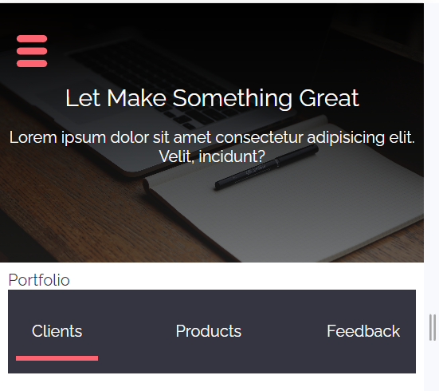

Requirements:

1. Sticky navbar:

1. Form validation:

1. Details about other portfolio sections:

1. Add loader (you can use any)

1. The switch between sections should be carried out without reloading the page.

1. Add error handling: A screenshot of a computer

   Description automatically generated
2. Side menu:

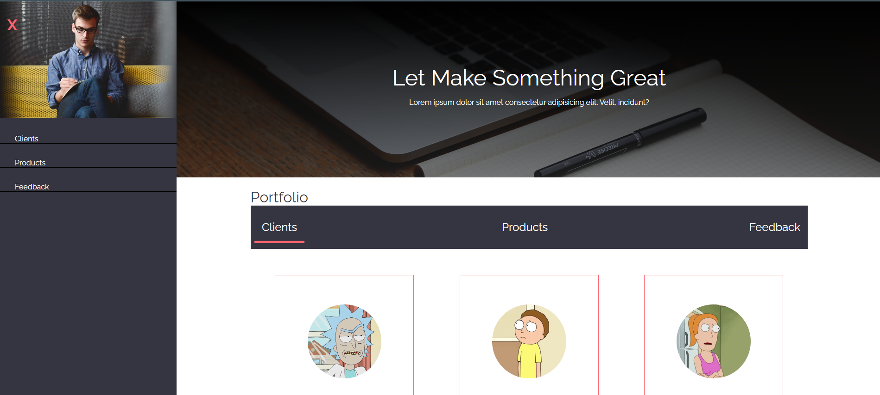

1. List of APIs:

<https://rickandmortyapi.com/api/character>

https://fakestoreapi.com/products?limit=6

https://fakerapi.it/api/v1/texts?_quantity=6&_characters=300

1. Assets:





Svg-icon:

    <svg viewBox="0 0 488 488" id="burger-menu">

        <path d="M64.192,108.444h359.617c29.943,0,54.223-24.278,54.223-54.222C478.031,24.278,453.754,0,423.809,0H64.192

            C34.248,0,9.969,24.278,9.969,54.222C9.969,84.166,34.248,108.444,64.192,108.444z"/>

        <path d="M423.809,189.778H64.192c-29.944,0-54.223,24.278-54.223,54.222c0,29.943,24.278,54.223,54.223,54.223h359.617

            c29.945,0,54.223-24.279,54.223-54.223C478.031,214.056,453.754,189.778,423.809,189.778z"/>

        <path d="M423.809,379.557H64.192c-29.944,0-54.223,24.277-54.223,54.222C9.969,463.722,34.248,488,64.192,488h359.617

            c29.945,0,54.223-24.278,54.223-54.222C478.031,403.834,453.754,379.557,423.809,379.557z"/>

    </svg>

1. Styles:

Font-family: "Raleway", sans-serif;

"https://fonts.googleapis.com/css2?family=Raleway:wght@400;700&display=swap"

    --color-red: #fb6470;

    --color-dark: #353541;

    --color-white: #fff;

    --color-blue: #0093b5;

